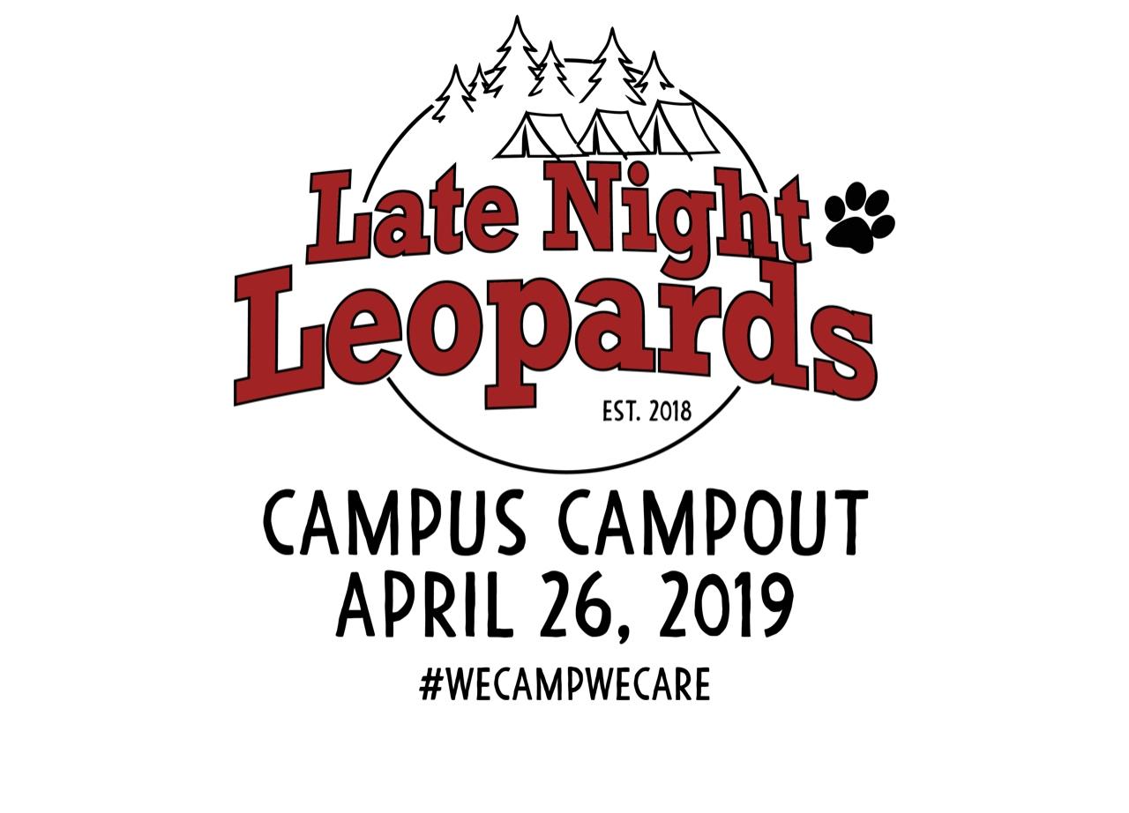

Lovejoy Friends,

As you may know, Lovejoy ISD has again suffered a loss of state funding. That loss is projected to be around $1.5 million dollars this year. As a result, many of the programs that make our school district one of the best in Texas have been put in jeopardy. Because of this significant deficit, last year we launched a new fundraising project at the elementary level: Late Night Leopards Campus Campout. Our goal for the 2018 campout at Puster Elementary was to raise $100,000 and we're pleased to report that, through in-kind and sponsorship dollars, we exceeded the goal in our inaugural year! With over 70% of Puster families participating, we had 200 campsites and 502 happy campers enjoying an evening of outdoor family fun!
The money raised is already making a difference: $30,000 was used at the district-level and the balance of Campout proceeds went directly back to Puster Elementary. Consideration was given to projects that would touch every student on the campus. Funds were used to:
- create and give a much-needed update to a computer/collaboration lab,
- enhance hands-on STEM-based workstations in the library, and
- hire a math interventionist to assist Puster students who need assistance or enrichment in math.

Our second annual campout is scheduled for Friday, April 26, 2019. This year our goal is to increase our fundraising by 20% to $125,000. We know we can reach this goal with partners like you in our community. As was the case last year, the funds raised at our campout will be distributed with a dollar amount going to Lovejoy ISD, and the balance going to Puster Elementary.
Would you consider sponsoring an event at the Puster Elementary Late Night Leopards Campus Campout to help us raise money for our school and district?
Our 2018 Campus Campout was a huge success due to businesses like you that sponsored activities at our Campout, including the movie under the stars, glow dance party, rock climbing wall and giant hamster wheel, just to name a few. These activities are an important part of what makes the Campout so special and memorable for the kids. If you choose to sponsor an activity, our families would be so grateful for your support. In appreciation of your generous donation, we are able to offer different sponsorship packages that would place your company logo/brand in front of over 200 families. Don’t miss this opportunity to advertise your business directly to nearly 500 residents in our community! We hope we can count on your help to make the 2019 Late Night Leopard Campus Campout a success.

In this packet, you will find our levels of sponsorship. Once you have had a chance to review the information, please include your donation in the self-addressed, stamped envelope included. Commitment letters are due by December 21, 2018, and all payments will be due in full no later than January 16, 2019. Please feel free to come by our campus to see what great programs we offer and why we are working to keep them in our schools! Puster Elementary is located at 856 Stoddard Road, Fairview, Texas 75069.

Thank you in advance for your valuable donation and sponsorship! You are helping students continue with the best education public school has to offer! We hope to see your company represented at our Late Night Leopards Campus Campout!

Sincerely,
Amy Bowers
2019 Underwriting/Sponsorship Chair
pustercampout@gmail.com
214-551-9396

Package Level | Lead Sponsor | Camp Boss | Camp Counselor | King of the Hill | Trail blazer
Donation Amount | $7,000 and up | $5,000 | $2,500 | $1,000 | $500
Sponsorship Package Choice | I | I | II | IV | V
Identification as lead sponsor on all promotion of the event "Late Night Leopards Campout sponsored by…" | *
On site presence during registration period | *
Featured promotional item of choice provided by the sponsor | *
Logo included on t-shirts (font size based on level of giving) worn by volunteers at the event | *
On site presence (subject to approval) the week before event  (priority placement) | * | *
On site presence during the event (subject to approval) | * | *
"Shout Outs" during the event | * | * | *
Name and logo included on registration packet if funds received by January 1, 2019 | * | * | *
Name included on the back of kid t-shirts (font size based on level of giving) worn by kids at the event | * | * | * | *
Logo or company name on the pustercampout.com website with a link to sponsor’s website | * | * | * | * | *
Logo on sign at sponsored activity during the event | * | * | * | * | *
Promotional item in check-in bag (optional and provided by the sponsor) | * | * | * | * | *
Recognition in event packet | * | * | * | * | *
Sponsor Benefits

2019 Puster Campout Activities

In order of preference, please select three activities you would like to sponsor under the appropriate sponsorship level. We will honor your first choice, if still available when your packet is received. Note that events/activities are subject to change. All 2018 Sponsors will have the right of first refusal for the 2019 campout. Sponsor benefits for in-kind donations will be based on fair market value.

Lead Sponsor $7000
Lead Sponsor – Reinhard Real Estate

Level 1 – Camp Boss Sponsor $5,000
- Camper Dinner Sponsor SPONSORED | - Early Bird Breakfast Sponsor
- Glow Party Sponsor SPONSORED | - Dad Zone (Wrestling and Koozies) Sponsor
- Home Base (Flashlights) Sponsor | - I don’t have a preference. Plug me in where it makes sense.

Level 2 – Camp Counselor Sponsor $2,500
- Petting Zoo Sponsor | - Camp Captain’s T-shirt Sponsor SPONSORED
- Volunteer T-shirt Sponsor | - Hungry Hippos Sponsor
- Movie Time Sponsor | - Back Pack Sponsor SPONSORED
- Hamster Wheel Sponsor | - Inflatable Soccer Wheels Sponsor
- Climbing Wall Sponsor | - Putt Putt Sponsor
- I don’t have a preference. Plug me in where it makes sense.

Level 3 – King of the Hill Sponsor $1,000
- Super Slide Sponsor | - Camp Memories Photo Sponsor
- Campfires and Smores Sponsor SPONSORED | - Glow in the Dark T-Shirt Deco Station Sponsor
- Mechanical Bull Sponsor | - Obstacle Course Bounce House Sponsor
- Laser Tag Sponsor | - Band-Aids and Boo Boos Sponsor
- Coffee Refuel Station SPONSORED | - Golf Cart Sponsor
- Coffee Cup Sponsor SPONSORED | - Midnight Snack Sponsor
- Water Bottle Sponsor SPONSORED | - Mom Zone Sponsor
- Pony Rides Sponsor SPONSORED | - I don’t have a preference. Plug me in where it makes sense.

Level 4 – Trailblazer Sponsor $500
- Toothbrush Sponsor SPONSORED | - Board Breaking Sponsor SPONSORED
- Face Painting Sponsor SPONSORED | - Touch Down Toss Sponsor
- Hair Painting Sponsor SPONSORED | - Six and Under Obstacle Course Sponsor
- Six and Under Bounce House Sponsor | - Glow Party Snack Sponsor
- Camp Staff T-Shirt Sponsor SPONSORED | - Teacher Zone Sponsor
- Beverage Station Sponsor | - Basketball Sponsor
- Cornhole Sponsor | - I don’t have a preference. Plug me in where it makes sense.

Underwriting/Sponsorship Contract

Name_______________________________________________________________________________________
Title (if applicable)_____________________________________________________________________________
Company Name (if applicable)____________________________________________________________________
Address ______________________________________________________________________________________
City _______________________________ State ______________________ Zip Code ______________________
Daytime Phone Number ______________________________ Fax Number _______________________________
Email Address

____________________________________________________________________________________________

Authorized Signature
____________________________________________________________________________________________

Underwriting / Sponsorship Opportunities: (Please check)
- $7,000 – Lead Sponsor
- $5,000 – Camp Boss
- $2,500 – Camp Counselor
- $1,000 – King of the Hill
- $500 – Trailblazer

- In-kind Donation (please state below what is being donated and the fair market value of the donation).

What:____________________________________________ FMV: $_____________________________

- Happy Camper – Wish to support the event through a donation of:

$__________________________________________________

Note: Sponsor benefits for Happy Camper donations will be based on the amount donated.

Puster Elementary Printing and Publications
We request your logo with a transparent background in vector format no later than January 1, 2019. Please print below your company name as you wish it to appear for underwriter/sponsorship listings on printed materials, when applicable. Print or type exactly as it should appear.

____________________________________________________________________________________

- I/we agree to provide Late Night Leopards with a print ready, transparent background, vector image logo via https://tinyurl.com/Puster2019
- I/we prefer not to be listed in any printed materials

- Please list as an Anonymous Donor

PAYMENT INFORMATION

Please make checks payable to Lovejoy Independent School District. Payment in full is due by January 14, 2019.
- Enclosed is my check. (Checks are preferred to avoid credit card transaction fees.)

Pledge Now and Pay Later (by January 14, 2019) to fully benefit from the amenities!
- Payment is to be received by: _________________________________

Return Underwriter and Sponsorship Contract by mail to:
Late Night Leopards
Puster Elementary – Bonnie Gundling
856 Stoddard Road
Fairview, Texas 75069
Or, scan and email to pustercampout@gmail.com.

As a nonprofit 501(c)(3) organization, all charitable contributions to the Lovejoy Independent School District are tax deductible to the extent allowed by the law.

The campout event will be held on the campus of Puster Elementary 856 Stoddard Road Fairview, Texas 75069 on April 26, 2019, rain or shine.

Date Contract Received: ______________________________________________________________________

